Project Design Phase-II

Data Flow Diagram & User Stories

Date | 12 March 2026
Team ID | 6997f7cc05fb21b07dca82fd
Project Name | Visualizing Housing Market Trends: An  Analysis of Sale Prices and Features using Tableau
Maximum Marks | 4 Marks

Data Flow Diagrams:
A Data Flow Diagram (DFD) is a traditional visual representation of the information flows within a system. A neat and clear DFD can depict the right amount of the system requirement graphically. It shows how data enters and leaves the system, what changes the information, and where data is stored.

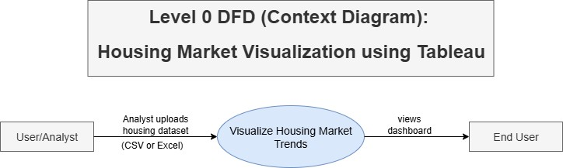

DFD Level 0 – Context Diagram Flow
- User/Analyst uploads housing data (CSV/Excel) into the visualization system.
- System processes the data and creates meaningful visualizations.
- End users (executives, analysts) view insights via an interactive Tableau dashboard.

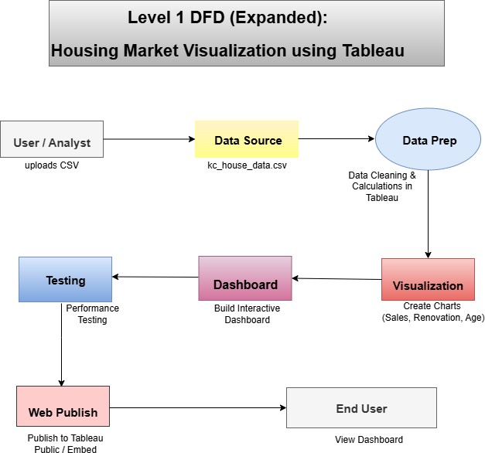

DFD Level 1 – Expanded Flow
- File upload and validation (check file type, structure).
- Handle missing/null values if present.
- Clean the data (e.g., format dates).
- Create calculated fields:
e.g., House Age, Years Since Renovation, Price/Sqft.
- Create charts using Tableau: Total Sales, House Age, Bedrooms/Floors comparison, etc.
- Combine visuals into a filtered interactive dashboard (with dropdowns/sliders).
- Load performance, filter functionality, field calculation checks.
- Publish to Tableau Public
Embed into a website / share with stakeholders

User Stories
Use the below template to list all the user stories for the product.

User Type | Functional Requirement  (Epic) | User Story Number | User Story / Task | Acceptance criteria | Priority | Release
Data Analyst | Data Upload | USN-1 | As a data analyst, I can upload the housing dataset to begin the visualization process. | Dataset is successfully  uploaded and read by Tableau. | High | Sprint-1
Data Analyst | Data Preparation | USN-2 | As a data analyst, I can clean and transform the dataset in Tableau. | Null values removed, calculated fields added (e.g., House Age). | High | Sprint-1
Data Analyst | Visualization Creation | USN-3 | As a data analyst, I can create charts based on renovation, house age, and features. | Visuals like bar/pie charts  are created and reflect accurate data. | High | Sprint-1
Viewer | View Dashboard | USN-4 | As a viewer, I can interact with the dashboard using filters. | Filters (e.g., Year, Region, Bedrooms) function  correctly. | High | Sprint-2
Executive | Dashboard Export | USN-5 | As an executive, I can export dashboard visuals for reports. | PDF/image exports are generated from Tableau dashboard. | Medium | Sprint-2
Admin | Dashboard Sharing | USN-6 | As an admin, I can publish or embed the dashboard on a website. | Dashboard appears embedded and accessible  to stakeholders. | Medium | Sprint-2

